**Users and Groups**

**sudo command**

**What is sudo?**

The sudo (superuser do) command gives some admin privileges to non-admin users

* When you put sudo in front of any command in terminal, that command runs with elevated privileges, which is why it's the solution to privilege-related errors.

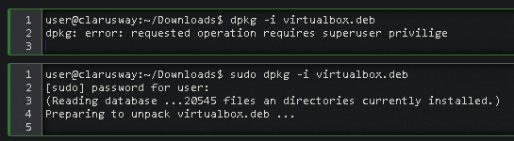

| **Commands** | **Meaning** |
| --- | --- |
| sudo -l | List available commands. |
| sudo command | Run command as root. |
| sudo -u root command | Run command as root. |
| sudo -u user command | Run command as user. |
| sudo su | Switch to the superuser account. |
| sudo su - | Switch to the superuser account with root's environment. |
| sudo su - username | Switch to the username's account with the username's environment. |
| sudo -s | Start a shell as root |
| sudo -u root -s | Same as above. |
| sudo -u user -s | Start a shell as user. |

**💡Tips:**

* If you're not sure if you're using sudo or su, look at the trailing character on the command line. If it's a pound sign (#), you're logged in as root.
* Use the su command to switch to the superuser (root), or you can use the sudo command instead.

**Using** sudo

**Q:** What does sudo mean?  
**A:** sudo is an abbreviation of “**su**per user **do**” and is a Linux command that allows programs to be executed as a super user (aka root user)

 - Interview Q&A

Formun Üstü

Next

Formun Altı

**Basic User Commands**

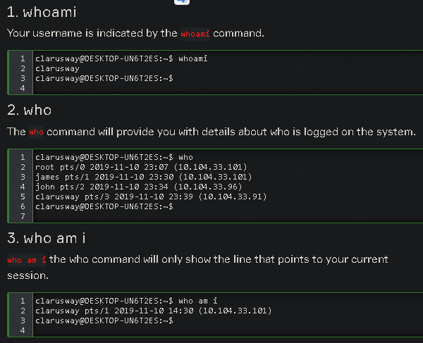

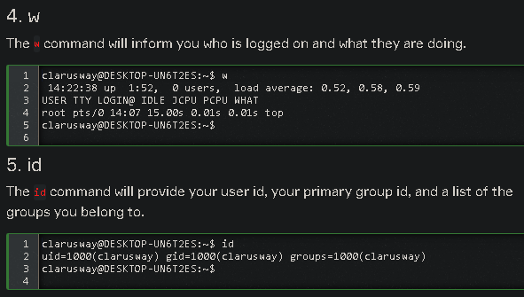

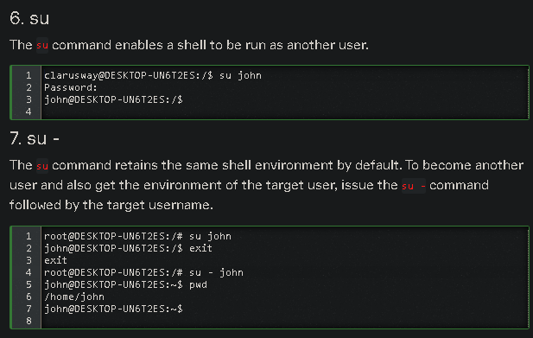

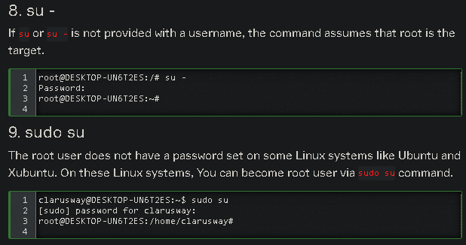

**User management**

Linux is a multiuser operating system. In a multiuser environment, it is a common administration task to create new users, modify existing users, or remove users. For ease of access management, users are assigned to groups. Creating, deleting, and modifying groups is also another common administration task.

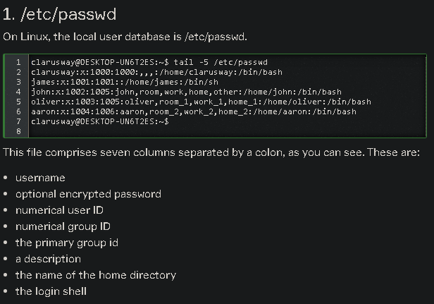

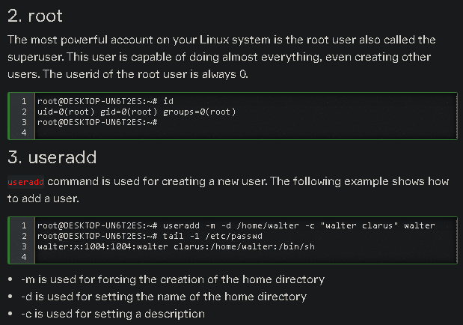

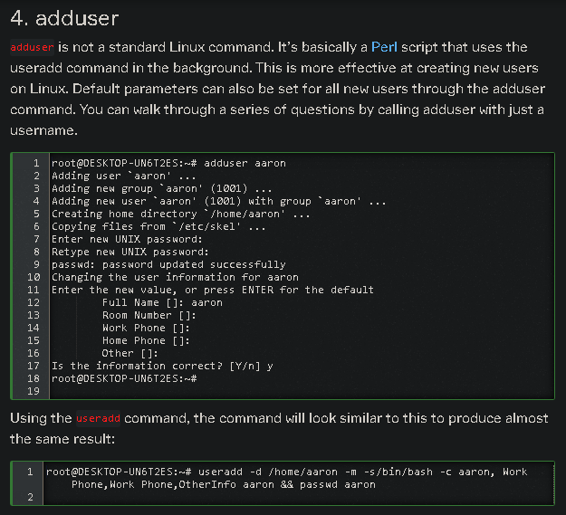

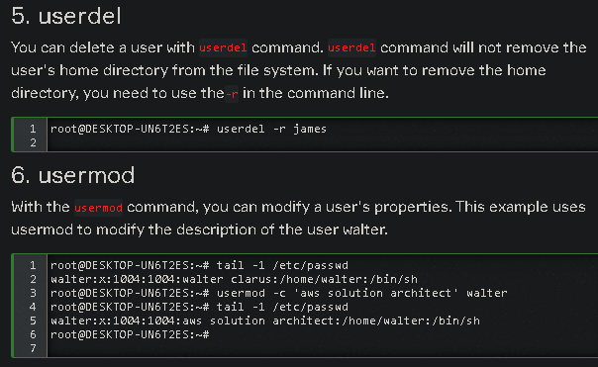

**User Passwords**

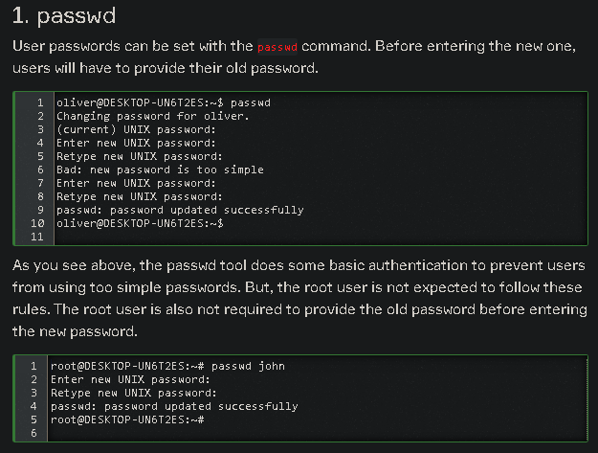

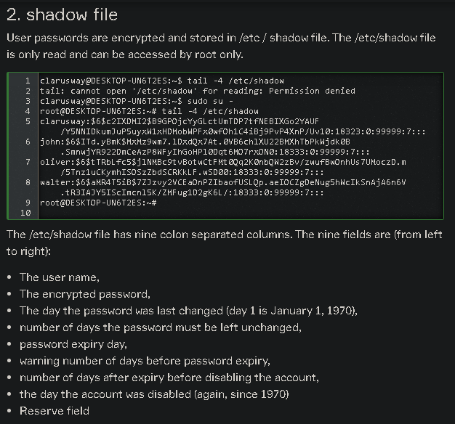

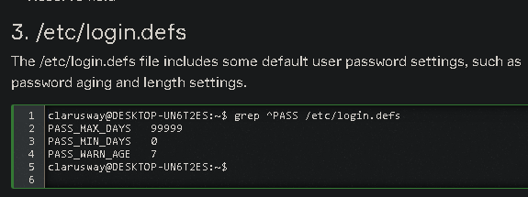

**Group Management**

Groups are a collection of users. Assigning users to groups makes it easier to manage permissions. For example, you can set permissions to ensure that files are accessible to people in a particular group like accounts, etc.

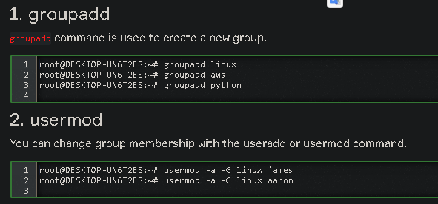

* Be careful when using usermod to add users to groups.
* By default, if the group is not specified in the command, the usermod command will remove the user from any group he/she is a member of!
* Using the -a (append) option prevents this behaviour.

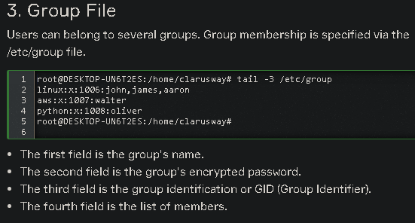

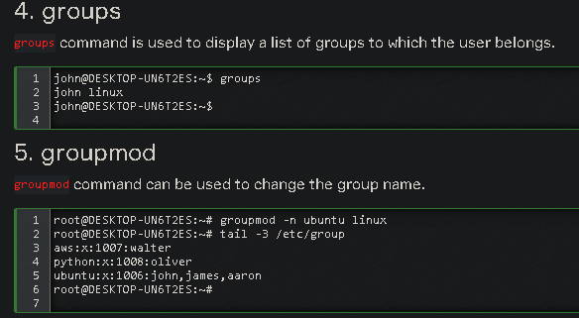

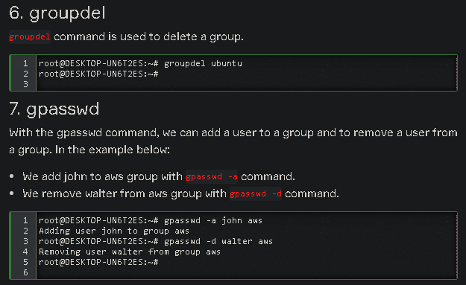

**Q:** how do you add a user to the sudo group  
**A:** I should follow these steps:

* Log in to computer or server as the **root user**.
* Use the **adduser** command to add a new user to system. (#adduser username)
* Use the **usermod** command to add the user to the sudo group. (#usermod -aG sudo username)
* Test sudo access on new user account. (# su - username)

 - Interview Q&A

Complementary Lesson about Managing Users and Groups :

<https://youtu.be/55SUZ7pEM_I>